NORTHERN ATHLETICS
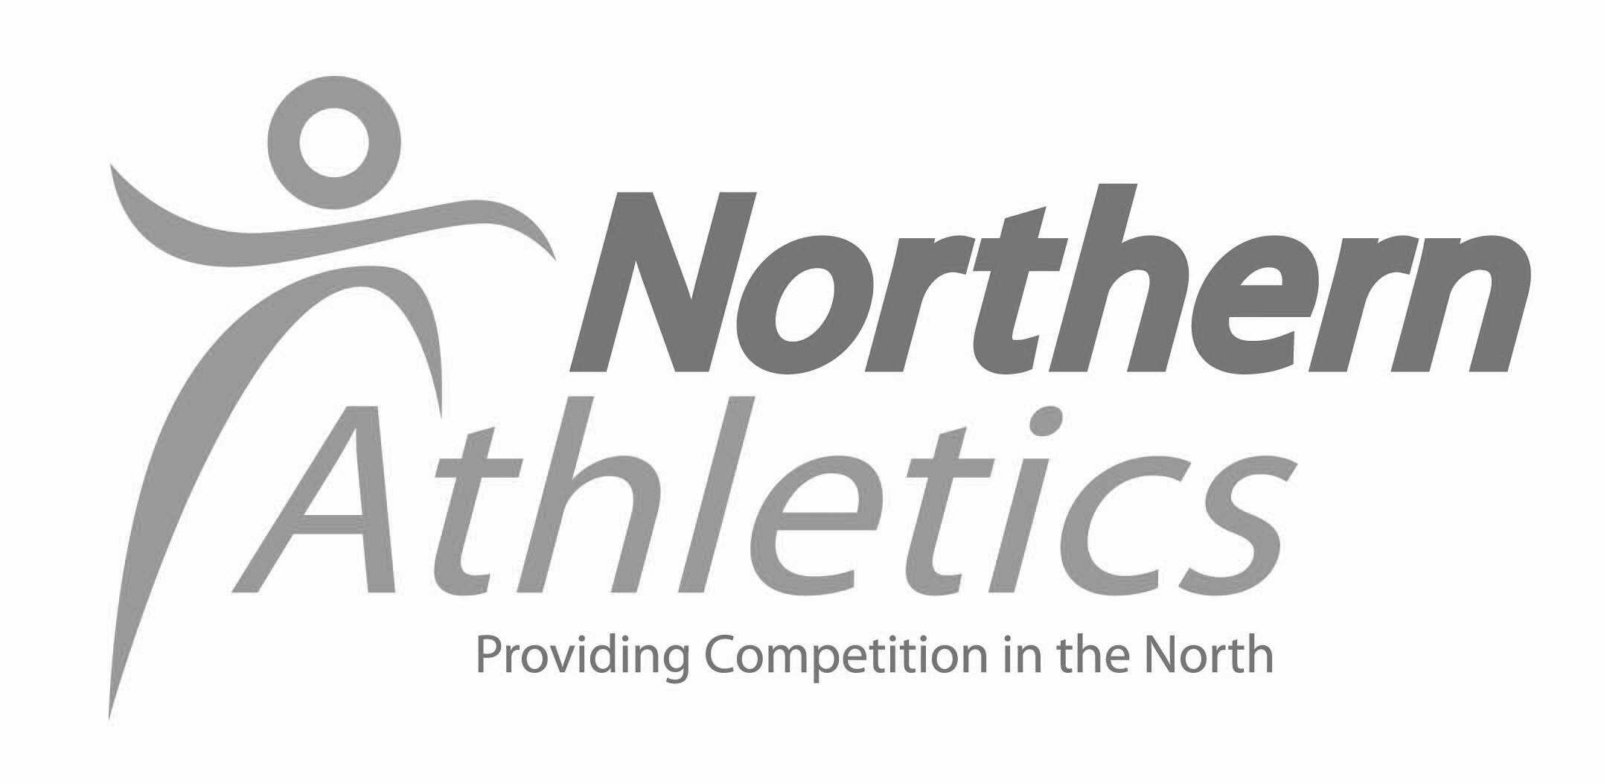
2018 ‘START FITNESS’ TRACK AND FIELD CHAMPIONSHIPS

The 2018 Track & Field Championships will kick off with the Senior, Under 20 event at Sport City, Manchester on the 9th & 10th June followed by our annual U17/ U15 Inter County event on 7th July at Leigh and closing at Liverpool’s Wavertree Stadium on 11th and 12th August with the U17,U15 and U13 Championships.

The senior event will once again host the Parallel Success athletes within the timetable but this year there will be an added bonus to the PS events with the inclusion of several ‘Invictus’ athletes who will be looking to improve their experience and performances at a mainstream event which will be a ‘first’ for many of them.

With the introduction of our proposed affiliation scheme, we are confident that our championship events will continue to improve and offer meaningful competition for athletes across the North whatever your event. This is your chance to experience a ‘proper’ Championship atmosphere whatever your level of ability.

Many athletes believe that they are ‘not good enough’ to compete in a Northern Championship BUT there are no entry standards and competing against athletes at a higher level will always result in improvement.

Once again we are offering all senior winners of County Championship events free entry to the Northern champs in the same event so if you are fortunate enough to win your county event please take the opportunity to enter the corresponding Northern event for free, you will receive an appropriate application form at your county event, if not please call or email me at the Northern office and I will be happy to send one on to you.

Our Inter County match features young athletes from all the ten counties that comprise the Northern area, it is an exciting and hotly contested event and someone WILL beat Yorkshire one of these days!
Entry to the event is only available to those chosen to represent their county team and you will be informed of your selection via your county team manager. No other entry method is available for this event.

However – the U17/U15 U13 Championships is open to all and will be held at the newly refurbished Wavertree Athletics Centre in Liverpool (home of Liverpool Harriers and Katerina Johnson-Thompson).

Once again no entry standards are needed to enter, just enthusiasm and effort, something which is never in short supply at this event.

So we look forward to seeing many more of you at this year’s Championships, let’s make it a record year for Northern Athletics and aim for the big time, starting at your annual area championships.

All events are electronically timed and results are posted on Power of Ten.

Entry to Championships is available online at www.race-results.co.uk

Any queries please contact Judith on judith@northernathletics.org.uk

